**Assignment-1**

<!DOCTYPE html>

<html lang = "en">

<head>

<title> A simple table </title>

<meta charset = "utf-8" />

</head>

<body>

<H1><center>STUDENT DETAILS</center></H1>

<fieldset>

<legend style="font-size:40px; color:Blue;"><b>Application Form</b></legend>

<table border="1px solid black">

<tr>

<td><form>

<label>NAME:</label>

<input type="text" name="FN" id="FN" placeholder="First Name">

<input type="text" name="SN" id="SN" placeholder="Second Name">

</form>

<tr>

<td>

<form>

<label>USN:</label>

<input type="text" name="USN" id="USN"></td></form>

</tr>

<tr>

<td>

<form>

<label>GENDER:</label>

<input type="radio" name="radio" id="radio">

<label>Female</label></label>

<input type="radio" name="radio" id="radio">

<label>Male</label></label></td></form>

</tr>

<tr>

<td>

<form>

<label>ADDRESS:</label>

<textarea name="radio" id="radio" rows="5" cols="40"></textarea></td></form>

</tr>

<tr>

<form>

<td><label>DOB</label>

<input type="date" name="dob" id="dob"></td></form>

</tr>

<tr>

<td>

<form>

<label>Mobile:</label>

<input type="text" name="USN" id="USN"></td></form>

</tr>

<tr>

<td>

<form>

<label>Email id:</label>

<input type="text" name="USN" id="USN"></td></form>

</tr>

<tr>

<td>

<form>

<label>Documents:</label>

<input type="checkbox" name="check" id="check">

<label>10th MC</label></label>

<input type="checkbox" name="radio" id="radio">

<label>Aadhaar card</label></label>

<input type="checkbox" name="check" id="check">

<label>PAN Card</label></label></td></form>

</tr>

<tr>

<td>

<form><label>COURSES:</label>

<select id="Course" name="Course">

<option value="CSE">CSE</option>

<option value="EC">EC</option>

<option value="MECH">MECH</option>

</select></form></td></tr>

<tr>

<td>

<form>

<input type="submit" value="SUBMIT">

<input type="submit" value="RESET"></td>

</form>

</table>

</fieldset>

<ul>

<li>Academics</li>

<ul>

<li>UG Cources</li>

<ol>

<li>BTECH</li>

<ol>

<li>CSE</li>

<li>EC</li>

<li>MECH</li>

</ol>

<li>BCA</li>

<li>BCom</li>

</ol>

<li>PG Cources</li>

<ol>

<li>MTECH</li>

<li>MCA</li>

<li>MCom</li>

</ol>

</ul>

<li>Contacts</li>

</ul>

</body>

</html>

mlOu

**Output**

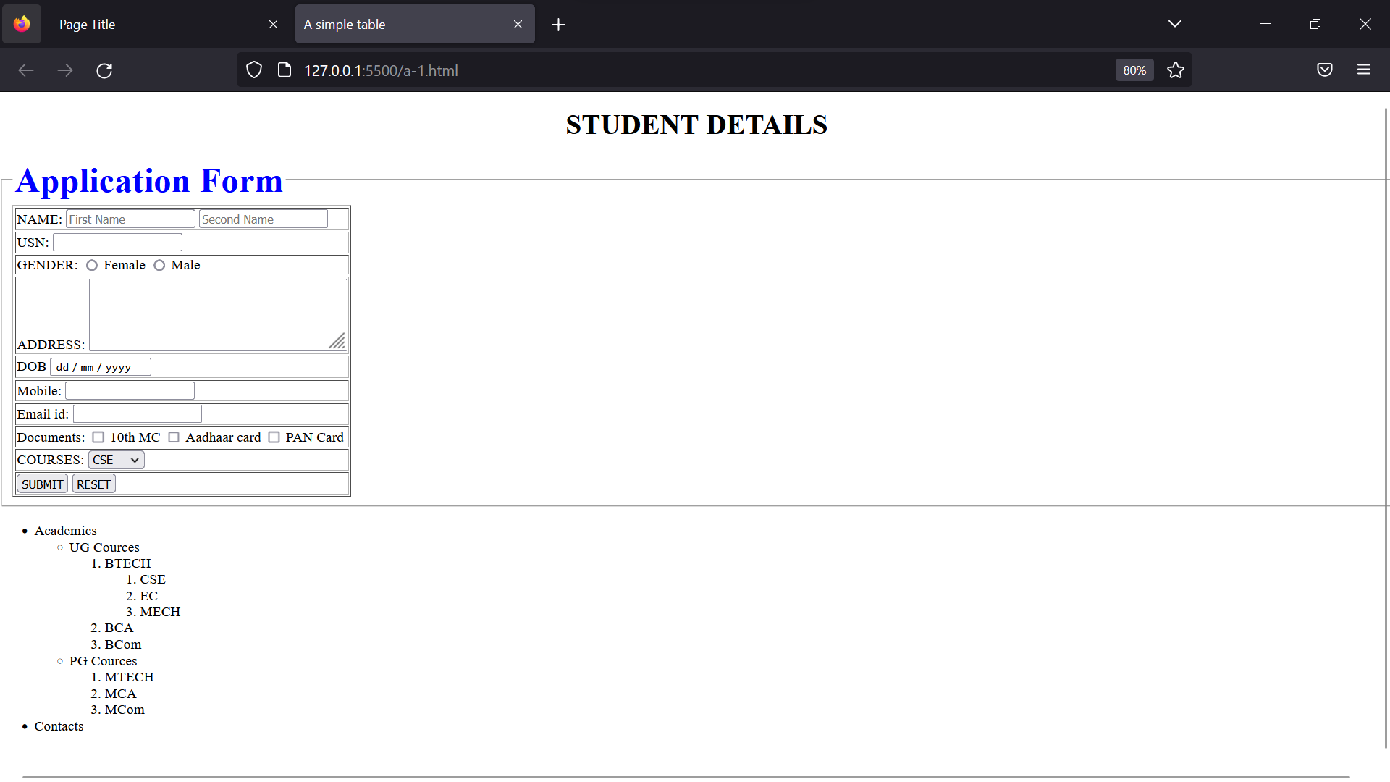

Open with Google Do